Project: SkillSphere – AI-Driven Career Readiness and Personalized Learning Recommendation Platform
System Architecture Diagram

Submitted in the partial fulfilment for the Course of
CSA1012 – SOFTWARE ENGINEERING
to the award of the degree of
BACHELOR OF TECHNOLOGY
IN
COMPUTER SCIENCE(AI)
Submitted by
R.Jalaja (192525365)
Under the Supervision of
DR ANITADAVAMANI K
SIMATS ENGINEERING
Saveetha Institute of Medical and Technical Sciences
Chennai-602105
Aug -2026

System Architecture Diagram & Explanation
1. Introduction
This document presents the system architecture for SkillSphere, an AI-driven platform that builds a competency profile for each student, analyzes skill gaps against career goals, and generates personalized recommendations for courses, projects, certifications and jobs. The architecture is derived from the platform's use case diagram, which identifies three primary actors Student, Faculty/Educator and Institution Administrator along with external systems such as job portals, certification providers and institutional ERP/SIS systems.
While a use case diagram describes what the system does and who interacts with it, the architecture diagram describes how the system is structured internally: the layers, components, and data flows that work together to deliver those use cases. The architecture below is organized as a layered (tiered) architecture, which is a common and easy-to-defend choice for web-based platforms that combine transactional services with machine learning.
2. Architecture Diagram
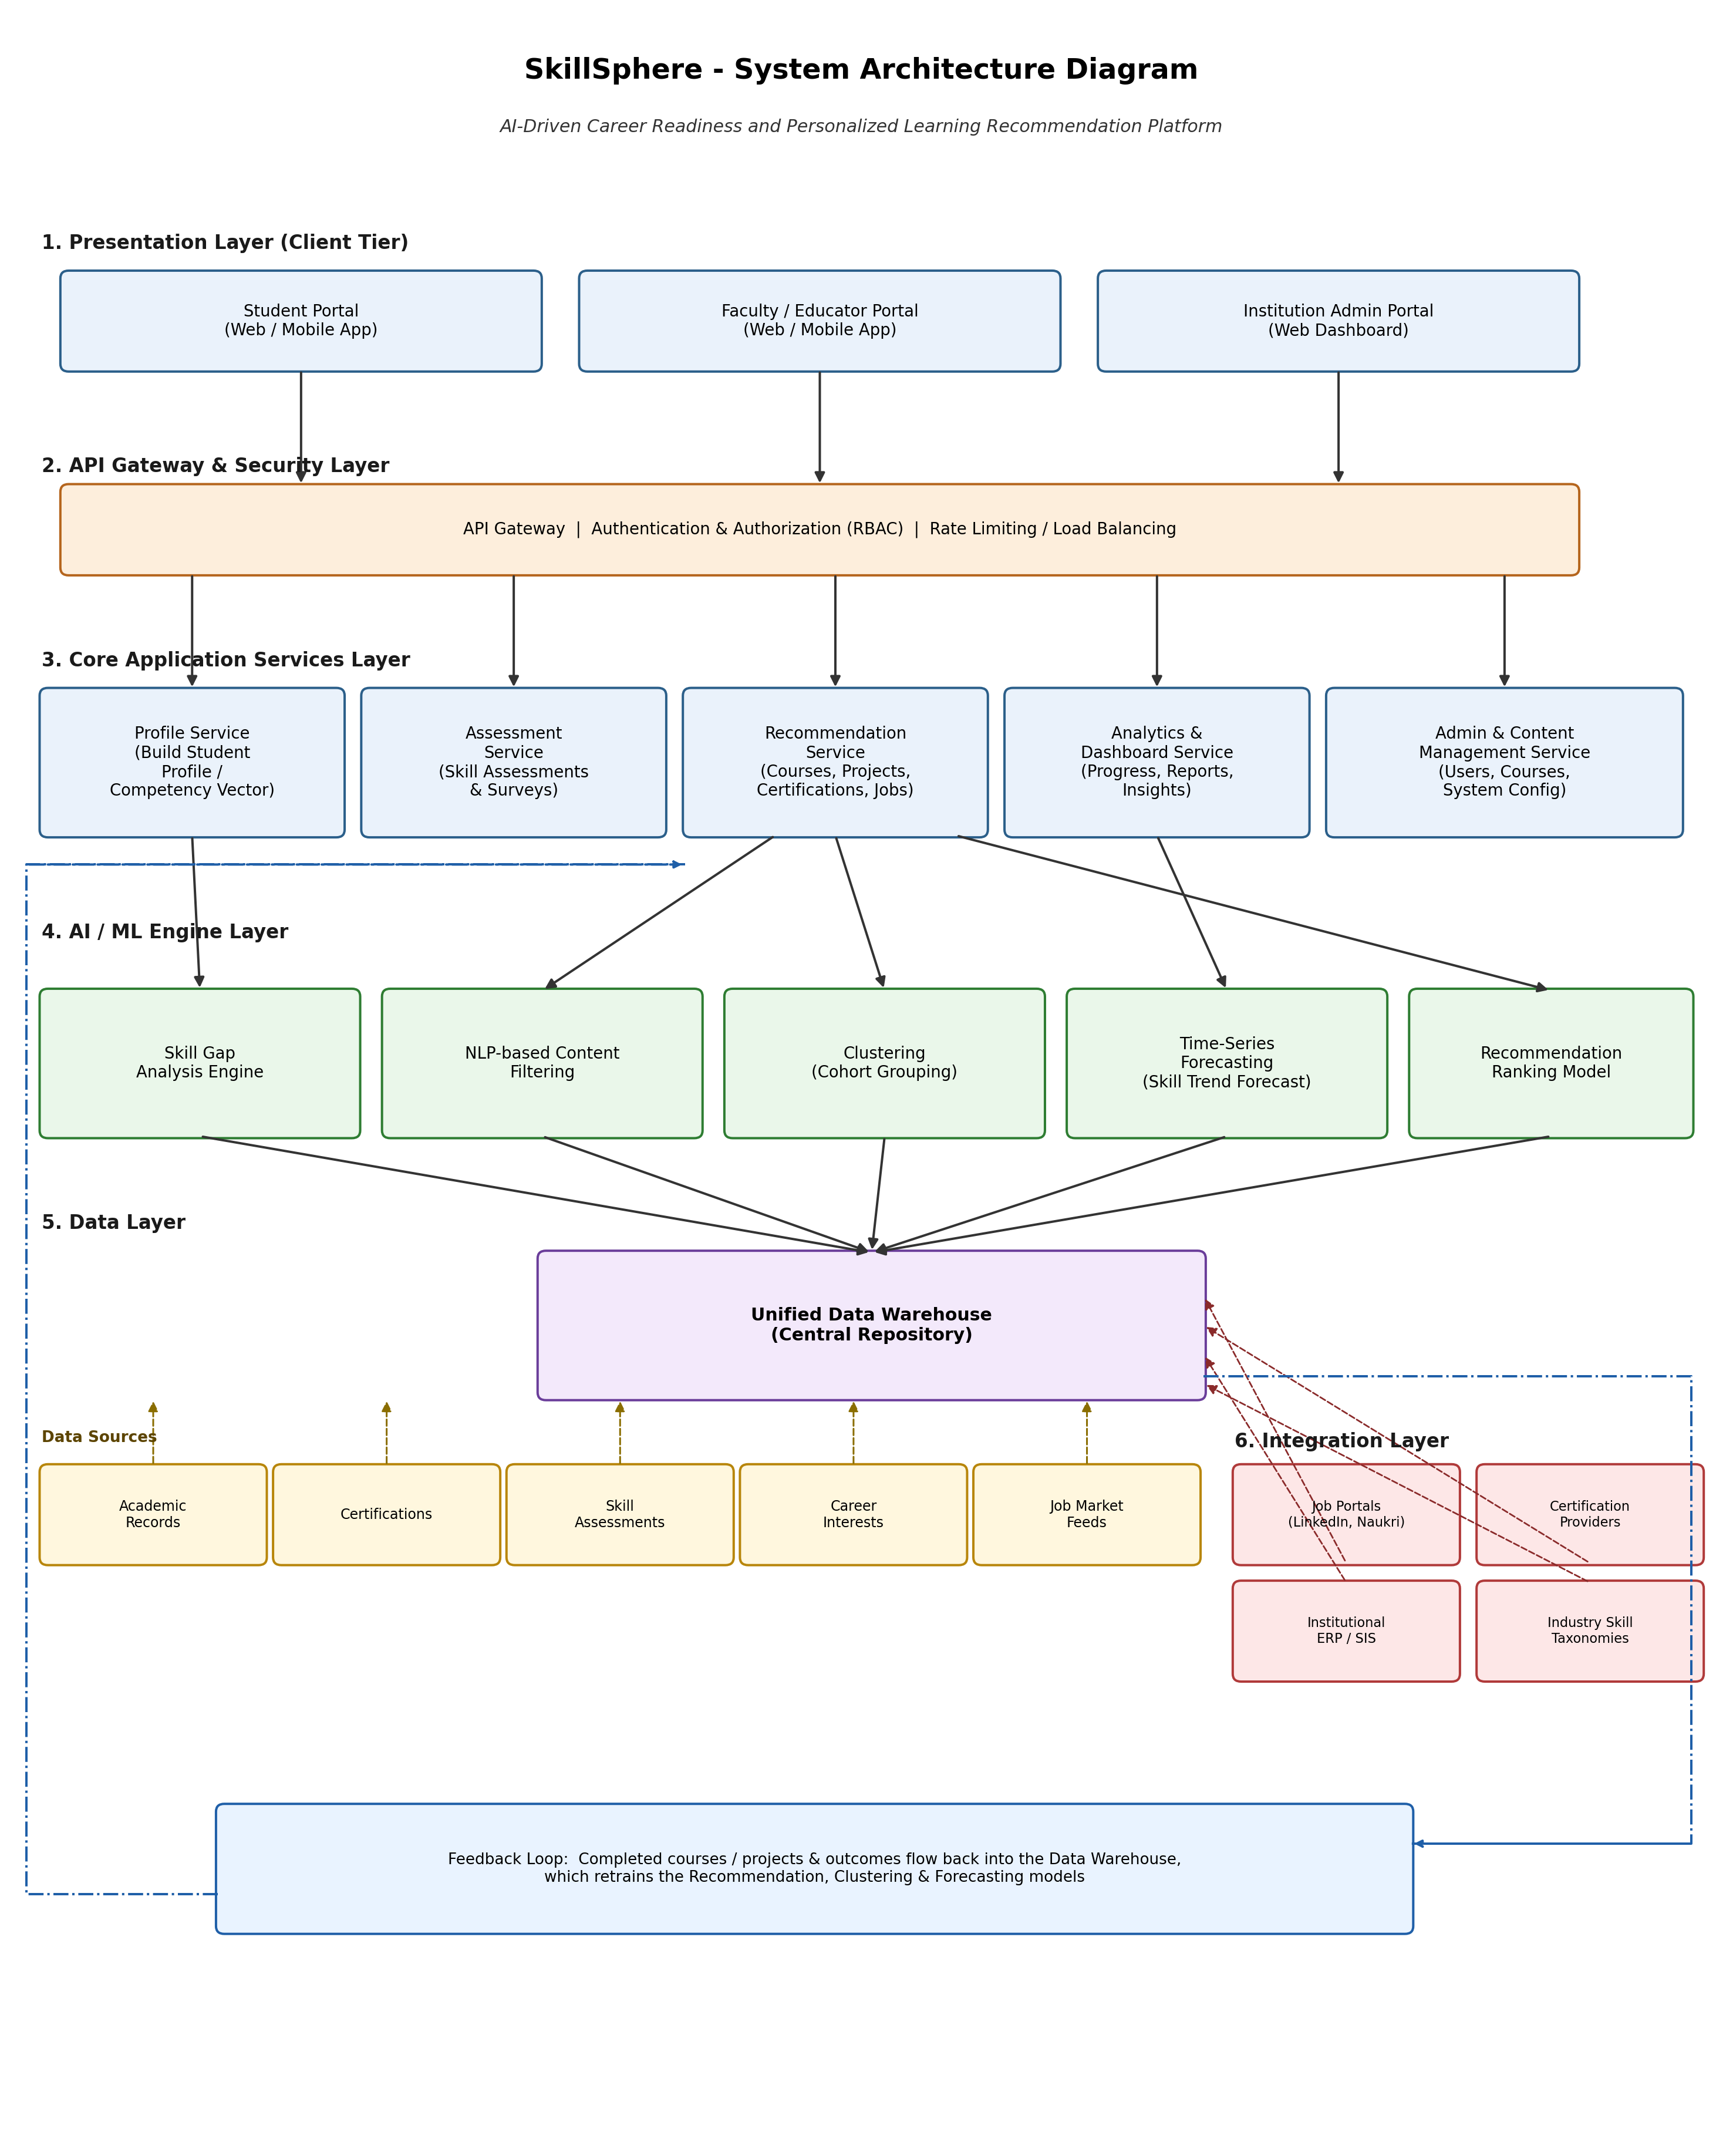

2.1 Use case diagram
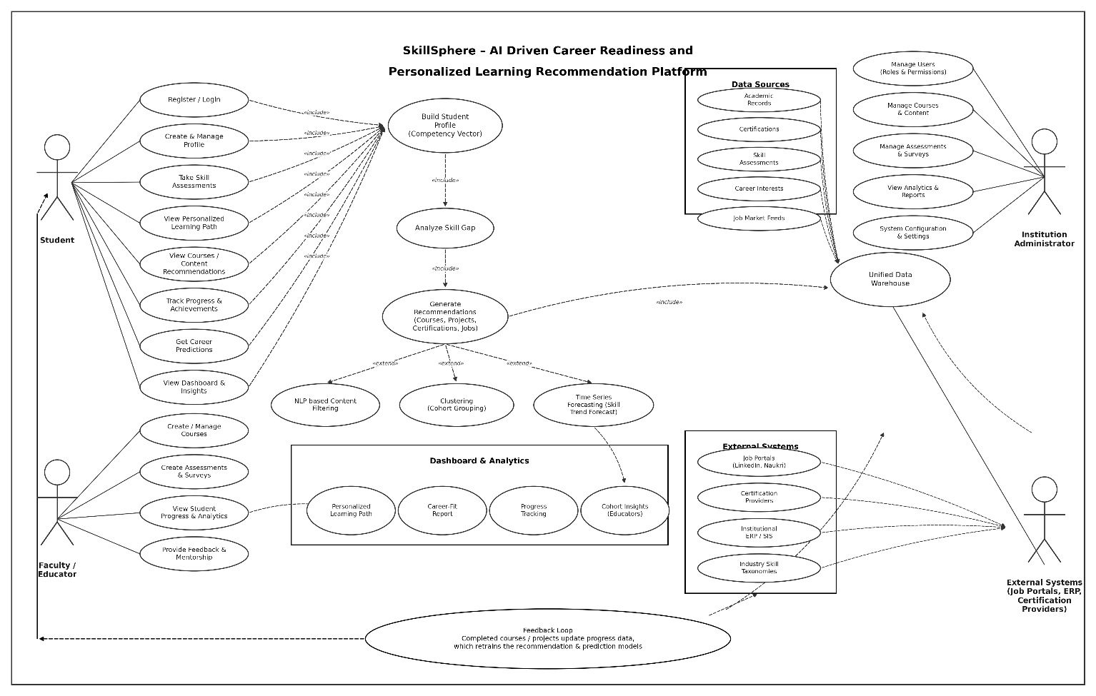

3. Layer-by-Layer Explanation

Layer | Purpose | Key Components
1. Presentation Layer | User-facing interfaces for each actor type | Student Portal, Faculty/Educator Portal, Institution Admin Portal (Web & Mobile)
2. API Gateway & Security Layer | Single entry point; enforces authentication, authorization and traffic control | API Gateway, Auth Service (RBAC), Rate Limiter / Load Balancer
3. Core Application Services Layer | Implements the platform's business logic as independent services | Profile, Assessment, Recommendation, Analytics & Dashboard, Admin/Content Management services
4. AI / ML Engine Layer | Runs the intelligence that powers personalization and predictions | Skill Gap Analysis Engine, NLP Content Filtering, Clustering, Time-Series Forecasting, Recommendation Ranking Model
5. Data Layer | Stores and consolidates all structured and unstructured data | Unified Data Warehouse; source feeds: Academic Records, Certifications, Skill Assessments, Career Interests, Job Market Feeds
6. Integration Layer | Connects the platform to third-party and institutional systems | Job Portals, Certification Providers, Institutional ERP/SIS, Industry Skill Taxonomies

3.1 Presentation Layer (Client Tier)
This is the layer end users directly interact with. It exposes three distinct interfaces because the platform serves three different actors with different needs: the Student Portal supports registration, profile building, assessments and viewing recommendations; the Faculty/Educator Portal supports course and assessment management, and viewing student progress; and the Institution Admin Portal supports user management, system configuration and institution-wide analytics. Building them as separate front-ends (or role-based views of one front-end) keeps each interface focused and simple.
3.2 API Gateway & Security Layer
All client requests pass through a single API Gateway before reaching any backend service. This layer is responsible for authenticating users, enforcing role-based access control (a student cannot access admin functions), rate limiting to protect the system from overload, and routing each request to the correct downstream service. Centralizing these concerns here means individual services do not need to re-implement security logic.
3.3 Core Application Services Layer
This layer contains the platform's business logic, split into independent services so each can be developed, scaled and deployed on its own:
- Profile Service — builds and maintains each student's competency vector from academic records, assessments and stated career interests.
- Assessment Service — delivers skill assessments and surveys and records the results.
- Recommendation Service — orchestrates the AI/ML engines to produce course, project, certification and job recommendations.
- Analytics & Dashboard Service — aggregates progress data into dashboards and reports for students, faculty and admins.
- Admin & Content Management Service — manages users, course content, and system-wide settings.
3.4 AI / ML Engine Layer
This layer is what makes SkillSphere “intelligent.” It sits behind the Recommendation Service and is called whenever a recommendation or prediction is needed:
- Skill Gap Analysis Engine — compares a student's current competency vector against the requirements of a target role.
- NLP-based Content Filtering — matches course and content descriptions to a student's skill gaps using natural language processing.
- Clustering (Cohort Grouping) — groups students with similar skill profiles so faculty can see cohort-level insights.
- Time-Series Forecasting — projects future skill demand from historical job-market trends.
- Recommendation Ranking Model — combines the outputs above into a final ranked list of recommendations.
Separating this layer from the core services is a deliberate architectural choice: ML models are retrained and redeployed on a different cadence than business logic, and they typically need different infrastructure (e.g., GPU compute), so keeping them as distinct, swappable components is good practice.
3.5 Data Layer
The Unified Data Warehouse is the single source of truth for the platform. It consolidates data from five source feeds — academic records, certifications, skill assessments, career interests and job market feeds — into a consistent structure that both the application services and the AI/ML engines can query. Centralizing data this way avoids inconsistencies that would arise if each service kept its own private copy.
3.6 Integration Layer
SkillSphere does not operate in isolation. The Integration Layer connects it to external systems: job portals (e.g., LinkedIn, Naukri) for live job postings, certification providers for verifying credentials, institutional ERP/SIS systems for academic records, and industry skill-taxonomy providers for keeping the platform's skill definitions current. These integrations feed data into, and in some cases pull data from, the Unified Data Warehouse.
3.7 Feedback Loop
A distinguishing feature of this architecture is the closed feedback loop: as students complete courses, projects and certifications, their updated outcomes flow back into the Data Warehouse. The AI/ML engines are periodically retrained on this fresh data, so recommendation quality improves over time rather than staying static. This loop is what makes the system adaptive rather than a one-time recommendation engine.
4. Data Flow Summary
A typical request flows through the architecture as follows: (1) a student logs in through the Presentation Layer; (2) the request passes through the API Gateway for authentication; (3) the Profile Service builds or updates the student's competency vector using data drawn from the Data Layer; (4) the Recommendation Service invokes the relevant AI/ML engines (skill-gap analysis, NLP filtering, clustering, forecasting); (5) the engines read from and reference the Unified Data Warehouse, which is itself kept current by the Integration Layer; (6) a ranked set of recommendations is returned up through the API Gateway to the Student Portal; and (7) as the student acts on these recommendations, outcomes are written back to the Data Warehouse via the feedback loop, improving future recommendations.
5. Conclusion
The SkillSphere architecture uses a layered design that cleanly separates client interfaces, security and routing, business logic, machine-learning intelligence, data storage, and external integrations. This separation makes the system easier to build, test, scale and maintain: each layer can evolve independently, the AI/ML layer can be improved without touching the front-end, and new data sources or external partners can be added through the Integration Layer without disrupting the rest of the platform. The closed feedback loop further ensures the system's recommendations stay accurate and relevant as students progress and the job market evolves.

